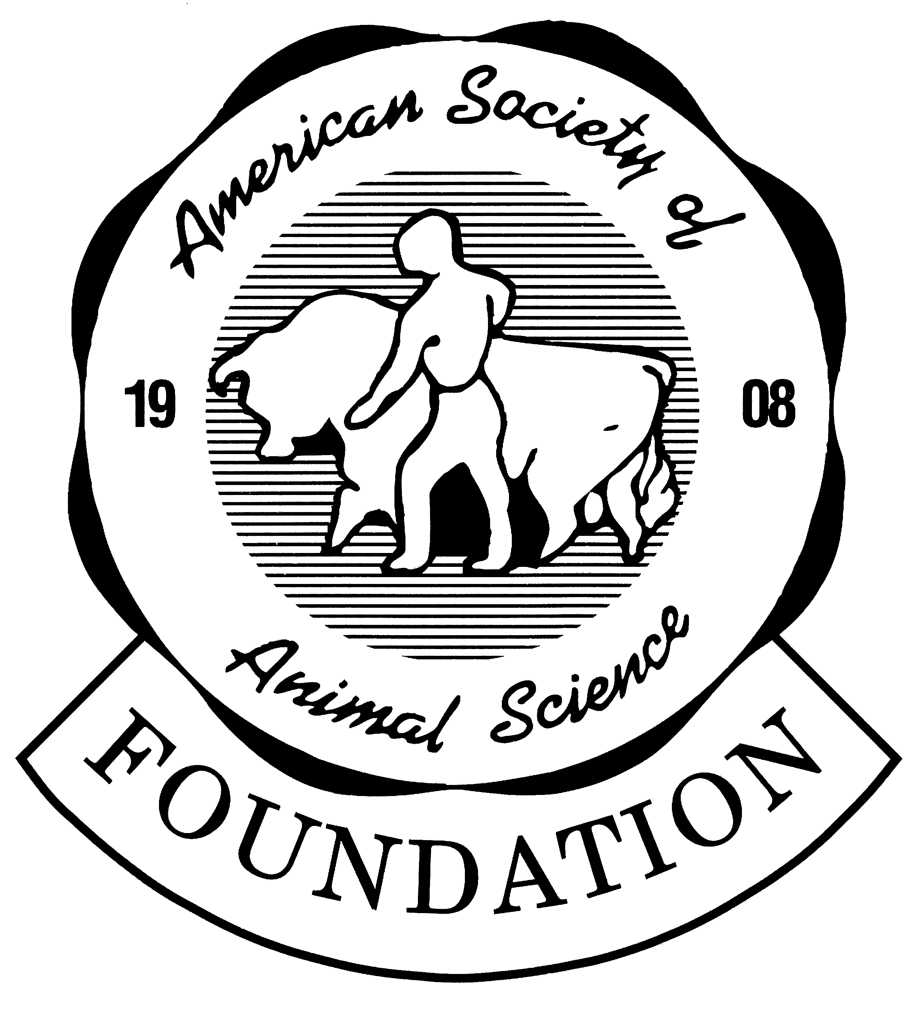

# American Society of Animal Science Foundation

PO Box 7410 • Champaign, IL 61826 • 217.356.9050 FAX 217.689-2436



Dear :

I hope that all is well for you and your family. I am writing to seek your financial support for an American Society of Animal Science (ASAS) Foundation “Appreciation Club” fund established in honor of **Dr. Rodney L. Preston**. ASAS Appreciation Clubs provide a unique opportunity to recognize mentors and/or colleagues who have influenced our careers and businesses and to make a contribution to special activities in the name of the honored person. I will be sending a similar letter to select companies whom we thought would like to contribute to such a program honoring Dr. Preston and be recognized as “Club Founders.”

Before I became involved, I had only a cursory understanding of the Appreciation Clubs. Appreciation Clubs were established by the ASAS Foundation to honor individuals who have had major impacts as mentors and Animal Science Professionals, and to support activities such as ASAS symposia, invited lectures, student scholarships etc. I have volunteered to serve as the chairperson responsible for fundraising at the request of the Trustees. Drs. Deana Hancock, Robbi Pritchard, Dave Hutcheson and Dave Anderson have also agreed to help with this effort. As part of the process to establish such a program in Dr. Preston’s name, I spoke with Rod and discussed how he envisioned such a fund being used. Dr. Preston asked that the funds be used to fund activities that “Keep science in Animal Science. One of the options under consideration is an annual award given to innovative research presented at the National ASAS meetings bearing Rod’s name. Only earnings from the principal balance will be spent. The funds will be managed by the ASAS Foundation Board of Trustees in a manner such that the principal balance is grown over time in concert with inflation.

A “fully funded” Appreciation Club in the name of Dr. Preston will provide a public acknowledgment of his professional accomplishments, which have been national and international in scope. I think that we all are well-versed in his accomplishments, but a brief biography for Dr. Preston is attached. I know that all of us have substantially benefitted from the guidance of Dr. Preston over the years.

Donors to Dr. Preston’s Appreciation Club will be recognized at the annual ASAS meetings in Vancouver, British Columbia during the awards ceremony and/or symposia. A plaque will be presented to Dr. Preston that **will list the names of the Club Founders**. To become a Club Founder, we are asking for a minimum corporate donation of $2,000 or individual donation of $500. Club Founders will be recognized by name at the annual ASAS awards banquet as well as on the ASAS Foundation’s web page.

The Rod Preston Appreciation Club will be considered “fully funded” when a minimum of $50,000 is reached; my hope is that we can reach this goal before the annual ASAS meeting in 2018 in Vancouver., BC, which would allow us to present to Dr. Preston the plaque and commemorate the beginning of his Appreciation Club.

The American Society of Animal Science is a non-profit 501(c)(3) charitable organization, so all gifts to Dr. Preston’s Appreciation Club are tax deductible to the extent provided by law. However, all tax benefits should be verified through a professional financial advisor. To make a donation, visit the ASAS foundation web page (<https://www.asas.org/membership-services/foundation/asas-foundation-funds>) or mail your donation to: ASAS Foundation, P.O. Box 7410, Champaign, IL 61826. If you prefer, please contact the ASAS office at 217-356-9050 and they will take your pledge and generate an invoice for your donation.

Cash, personal check, money order or bank draft are the most popular methods of charitable giving, but other options are available should you so choose. I would suggest contacting ASAS Foundation directly if you would like to contribute by other means. Checks should be made out to the ASAS Foundation and should be sent along with a letter indicating specifically that the gift should be credited to the Rod Preston Appreciation Club. All contributions will be acknowledged with an email receipt and a letter from the Foundation chair, Dr. Steve Bartle. For more information, you may contact ASAS directly at 217-356-9050.

As you are quite aware, Dr. Preston has contributed immensely to our knowledge of beef cattle nutrition, growth physiology, and management, and welfare. I am hoping that you will be willing to provide a financial donation to the ASAS Appreciation Club that has been established in Dr. Preston’s honor. In a small way, this will allow all of us whom have benefitted so much from Dr. Preston’s work to give something back. Thank you very much, in advance, for your consideration of my request.

Sincerely,

Steve Bartle

Deana Hancock

Robbi Pritchard

Dave Hutcheson

Dave Anderson