Title with a maximum of 120 keystrokes, including spaces

A.B. First^{1*}, C.D. Second², and E. Third³

¹ Company orInstitution, City, Country; ² Company or Institution, City, Country; ³ Company or Institution, City, Country; *Presenting and corresponding author: firstauthor@iastate.edu

Introduction
Submit your manuscript as an MS Word file (.docx). We expect you to submit 4 pages maximum, including tables, figures, references, etc. Use Times New Roman, font size 12, except for Title (16), authors (14), and main headings (14), single spacing, one column, A4 paper, and 2.5 cm margins on all sides. ALL text needs to be right justified. Avoid symbol font for special characters. Manuscripts not written in acceptable English will not be considered for publication. Do not use indents (except for equations or formulas) and no blank lines between paragraphs and no subheaders. Right justified text. Do not include an abstract – we will use the abstract that you have already submitted.
Do not include subheaders in the introduction.
References should be imbedded in the text as Meuwissen et al. (2001) or Lynch and Walsh (2008). Or as (Meuwissen et al., 2001; Lynch and Walsh, 2008; Ducroc and Wiggans, 2015; World Health Organization, 2004).
Abbreviations should be given in full on first use, followed by the abbreviation in parentheses. E.g. average daily gain (ADG). Use SI units in abbreviations; units should be given as kg/ha rather than kg ha⁻¹. Use commas for numbers equal to or greater than 1000 (e.g. 1,000). Periods need to be used for decimals. Use a 0 before the decimal point for numbers less than 1 (e.g. 0.005).

Materials & Methods
Do not use indents, except for important equations, and do not use more than one subheader level. Do NOT put blank lines between paragraphs. Use right justified text.
Formulas can be included as part of the text. Use uppercase italic for constants, lowercase italic for variables/scalars, lowercase bold for vectors, uppercase bold for MATRICES.
Important equations can be entered on a separate line, left indented, with right aligned numbering in brackets.
y=u+Z₁h+Z₂a+e (1)
Do NOT put blank lines around the equations. Give the meaning of all symbols immediately after the equation in which they are first used. Reference to numbered equations or formulas in the text by using Eq.1 etc.
Use a maximum of two header levels. Level 1 headings should be used for Introduction, Materials & Methods, Results, Discussion (or Results & Discussion), Conclusions, Acknowledgements (if needed), and References. Include a blank line before every header.

Subheader title. As just indicated, add a blank line before the subheader. After the subheader title, continue the text on the same line and in the same font size (12), right justified, and no blank lines between paragraphs.
As already indicated, do not include a blank line between paragraphs and do not use indents, except for important formulas or equations.

Subheader title. As just indicated, add a blank line before the subheader. After the subheader title, continue the text on the same line and in the same font size (12), right justified, and no blank lines between paragraphs.
Add a blank line before subheaders or level 1 headers, e.g. Results.

Results
Do NOT put a blank line between level 1 headers and the start of the text. DO add a blank line before and after each table and figure. Avoid large tables. Tables should fit on one (A4) page. Landscape format is not acceptable. Tables should be included in line in the text close to the location where it was first mentioned and justified or centred. Tables need to be clear without reading the text. Column headings should be brief and clear. Use horizontal lines only when necessary. Do not use vertical lines in tables. Use Times New Roman, font size 12 for the table content. Any necessary explanations essential for understanding the table should be given as a footnote at the bottom of the table. Use Arabic numbers for table footnotes.

Table 1. This is the table title, in regular font size 12, right justified. Do NOT put a blank line between the title and the table. End the title with a period.
 | Method A¹
 |  | Std |  |  | Method B²
Sample | Mean | X | Y |  | Mean | Std | Total
A | 1.5 | 0.2 | 0.1 |  | 1.8 | 0.30 | 3.3
B | 3.0 | 0.5 | 0.3 |  | 9.0 | 1.55 | 12.0
C | 2.2 | 0.6 | 0.5 |  | 1.8 | 0.09 | 4.0
¹ Use superscript numbers for footnotes and add these at the bottom of the table in font size 10 and indented such that the start of the text lines up.
² Footnote 2

More text. Leave one blank line between the end of the table (incl. footnotes) and the start of the new text. Reference to the table in the text as Table 1, etc.
Include one blank line before and after each table and figure. Figures can be black and white or in full colour. Legends can be included in the figure.

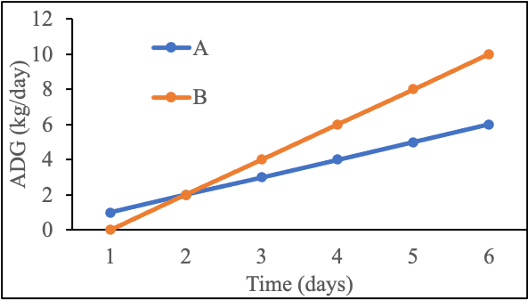
Figure 1. This is the figure title, which should be included below the figure without a blank line in between, and using justified text. Legends can be part of the figure. Center the figure.

More text. Include a blank line after the figure. Reference to figures in the text as Fig.1 etc. No blank lines between paragraphs. But include a blank line before of (sub)headers.

Discussion
Text of section. Results and discussion sections can be combined
Conclusions
A clear conclusions section is required.

Acknowledgements
Include if appropriate

References
Ducrocq V., and Wiggans G. (2015) Genetic Improvement of Dairy Cattle. In: Garrick D.J., and Ruvinsky A., The Genetics of Cattle. CABI, Oxfordshire.
Mäki-Tanila A., and Hill W.G. (2014) Proc. 10th WCGALP, Vancouver, Canada.
Meuwissen T.H.E., Hayes B.J., and Goddard M.E. (2001) Genetics 157:1819-1829. doi.org/10.1093/genetics/157.4.1819
Walsh B., and Lynch M. (2018) Evolution and selection of quantitative traits. Oxford University Press, Oxford.
World Health Organisation, The Global Burden of Disease: 2004 update. Available at: www.who.int/publications/i/item/9789241563710, visited on: 23-04-2025.

Do not include appendices

MAXIMUM 4 PAGES

Ethics
- Plagiarism in all its forms is unacceptable. If authors use the work and/or words of others this should be cited or quoted appropriately. If plagiarism or manipulation is identified, manuscripts will either not be considered for publication or if discovered after publishing the proceedings the chapter will be withdrawn from the electronic proceedings
- It is accepted that authors sometimes need to manipulate images for clarity, however, manipulation for purposes of deception or fraud will be seen as scientific ethical abuse.
- Authors need to confirm that all reported research meets the ethical guidelines, including adherence to the legal requirements (for human and animal studies) of the study country.

